Captures from Way Back When

Member protection

Member Protection

Members are covered by SLSNSW Workers Compensation for patrolling, club activities, sanctioned training activities and competition.

NSW WORKING WITH CHILDREN CHECK (WWCC)
Toowoon Bay SLSC has a strong interest in keeping children safe. As a club, we comply with the Child Protection Legislation where all members in a child related role (not covered by the exemptions) are holders of a current WWC. For more information please read the NSW Working with Children Guidelines.
To apply for a WWC please follow the process below and email your approved number to our Club Administration Support Officer at office.toowoonbayslsc@gmail.com or our approved Member Protection Information Officers at – mpio.toowoonbayslsc@gmail.com
Apply for NSW WWC number

MEMBER PROTECTION INFORMATION OFFICERS
A Member Protection Information Officer (MPIO) provides information about the rights, responsibilities and options available to an individual making a complaint. To learn more about how you can protect the welfare and wellbeing of all our members, most importantly that of the children and young people of our club, please contact our Member Protection Information Officers (MPIO’s) at mpio.toowoonbayslsc@gmail.com or read the Safeguarding Children and Young People Guideline
Would you like to become a Member Protection Information Officer? Or would you like more information on becoming one? Please visit the SLSNSW site Member Protection Information Officer for a helpful video and information on how to.

SAFEGUARDING CHILDREN AND YOUNG PEOPLE
Online resources including webinars, training course information, guidelines are available to all members at www.sls.com.au/safeguarding/ . This site provides guidelines for appropriate behavior when engaging with children and young people. The online Safeguarding Children and Young People Awareness Course is available to all members and is recommended to be completed by all members, not only those who work with children. To have this course recognised on your Surfguard awards listing, please complete the course via your members area then go to Elearning in the menu bar > log into Elearning > click on Training Library > click on “SLS – Safety and Wellbeing” view courses > enrol in “SLS Safeguarding Children and Young People Awareness Course. Course will take approximately 45 mins to complete.
- SLSA Safeguarding Children and Young People site
- SLSA Member Protection Policy 6.05 (inc General Code of Conduct) – Policy 6.05 – Member Protection
- Code of Conduct for People in Positions of Authority When Dealing with Children and Young People
- SLSA Social Media Policy 6.20 – Policy 6.20 – Social Media
- SLSA Privacy Policy 6.02 – Policy 6.02 – Privacy
- ALL RESOURCES ARE AVAILABLE FROM THE DOCUMENT LIBRARY IN YOUR MEMBERS AREA ACCOUNT – members.sls.com.au
- Safeguarding – Where to get help – SLS-Safeguarding_Where-to-get-help
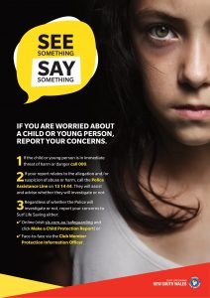
SLSA Reporting Guidelines
ALL members have a responsibility to speak up if they become aware of, or observe something considered inappropriate. Our MPIO Officers Karen Hickmott, Ben Stadelmann and Nicole Locker can be contacted via email at mpio.toowoonbayslsc@gmail.com or follow these guidelines below. Please be assured that all reports submitted will be held in the strictest of confidence and treated with the utmost respect for all involved:
Guide on How to Report Your Concerns About Child Safety
Guide on How to Make a Child Related Report
Video guide on how to report – https://www.youtube.com/watch?v=7dB3RnUxS_k&feature=youtu.be

Toowoon Bay Surf Life Saving Club is a member of Surf Life Saving Central Coast which includes fourteen other clubs on the NSW Central Coast spanning a coastline distance of 40kms.
Toowoon Bay Surf Life Saving Club was formed in 1954 by a dedicated group of volunteers wishing to ensure the local community and the many visitors to the area, experience a safe surf environment. In 1998 the club revised its constitution to ensure relevance and recognition that times had changed. Amid this change, the club maintained the strong belief in surf safety and education and training for all.
All aspects of surf life saving are enjoyed at Toowoon Bay including beach events, paddling boards and skis, rowing surf boats and swimming. All activites, some being competitive, are conducted in an environment of fun and family enjoyment.
This is in keeping with our motto : JOIN THE FUN!
To join TBSLSC or existing member renewals, go to: Members Portal Account

The FIRST Toowoon Bay SLSC Beach Patrol, Sunday 3rd October, 1954.
The Club President was Bob Roberts. The Club Captain was Gordon Hilton.
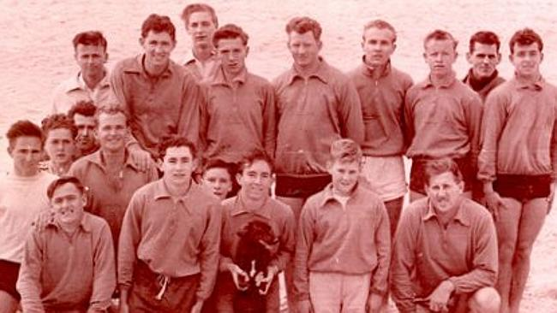
Photo : Left to Right
Back Row : Donald Newling, Max Haslett, Brian Byrnes, William ‘Bill’ Lees, Warren Johnson, Max Shean, Keith Jones, John Ringo
Middle Row : Dennis Tidy, George Freeman, Harold ‘Mike’ Bailey, T. Roberts
Front Row : Jim Starkey, Jeff Rolls, Keith ‘Roger’ Salmon, Digger Hilton, Gordon Hilton

